Predicting Doctor Fees
Many things in this world make us anxious. A “Medical Bill” is one of them. Now-a-days finding a doctor with an affordable consultation fee has become a huge task. If ever there was an option to predict the consultation fee of a Doctor, it would be a big help for many.
Problem Definition:
We have all been in a situation where we go to a doctor in an emergency and find that the consultation fee is too high. What if we have data that records important details about a doctor and we could build a model to predict the doctor’s consulting fee? This is the hackathon that lets you do that.
Click here to view the full code in GitHub repository.
Dataset Information:
The data consists of the following features. The dataset is available in my GitHub repository. Link to the train set. Link to the test set. Size of train set is 5961 and test set is 1987.

FEATURES:
- Qualification: Qualification and degrees held by the doctor
- Experience: Experience of the doctor in number of years
- Rating: Rating given by patients
- Profile: Type of the doctor
- Miscellaneous_Info: Extra information about the doctor
- Fees: Fees charged by the doctor
- Place: Area and the city where the doctor is located.
Loading the Data:
I have used the Pandas library for data loading and manipulation. Download the .xlsx files from the GitHub repository and use the pandas’ method read_excel() to load data. The train and test data are in separate files.
Click here to view the code.
Data Analysis:
Let’s look at the number of records in the train and test datasets using the df.shape. There are 5961 rows and 7 columns in the train dataset and 1987 rows and 6 columns in the test dataset. All the training and validations are done using the train set. I have used the train set as a base for all kind of scaling and transformations. The test set will be treated as a future unseen dataset. Click here to view the code.
Top 5 and bottom 5 records:
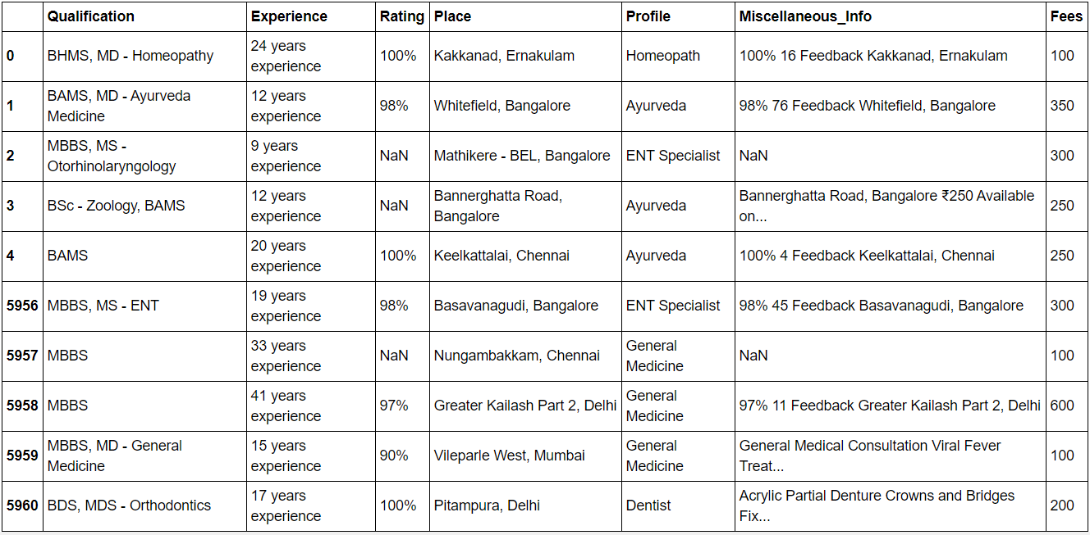
There are categorical as well as numeric variables in the dataset. The Qualification, Miscellaneous_Info and Place variables have multiple values in the same cell for most records. Experience variable has alphanumeric data and Rating variable has a special character in the values. Profile has string values and Fees; the target variable has numeric values and it is not class based. We are dealing with a regression problem.
There are null values in both train and test datasets. We can check for null values using the DataFrame.isnull().sum(). Click here to view the code.
Trainset missing data percentage:
Qualification 0.000000
Experience 0.000000
Rating 55.393390
Place 0.419393
Profile 0.000000
Miscellaneous_Info 43.952357
Fees 0.000000
dtype: float64

Test set missing data percentage:
Qualification 0.000000
Experience 0.000000
Rating 18.285523
Place 0.100654
Profile 0.000000
Miscellaneous_Info 13.990941
dtype: float64
Data Cleaning:
Experience:
There are no missing values in the Experience variable however, it has alphanumeric values. The number of years as an integer value and the text ‘years experience’ follows the number. It will be useful to extract just the number out of it and chuck the text. I have used regex for this. Click here to view the code.
Experience after extraction:
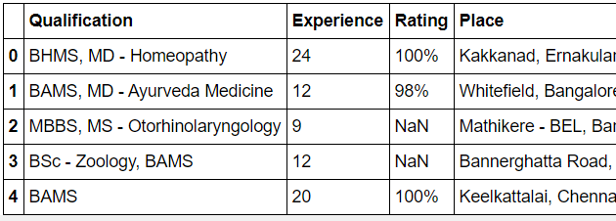
Place:
There are 25 missing values in the train set and 6 missing values in the test set. Looking at the records with missing values in Place, we see that the value in the Qualification variable for these records is ‘Get inspired by remarkable stories of people…’. These look like invalid values in Qualification variable, which will be dealt with in the ‘Feature Engineering’ part of this blog. For the Place variable, I filled the missing values with ‘Unknown,Unknown’ as we don’t know the place and we have 2 values in each cell for Place. For more details on the analysis and code, visit the GitHub link.
One record has ‘e’ as the value in ‘Place’ variable in the train set. I checked the train set to see if I can find the most frequent value in 'Place' for records with similar Qualification and Fees to replace 'e' with that value. There was a record with the similar Qualification and Fees. The Place for that record is ‘Chandra Layout, Banglore’. So, I replaced ‘e’ with ‘Chandra Layout, Banglore’.
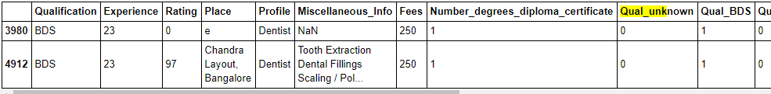
Rating:
In the ‘Rating’ variable, about 55% of values in the trainset and 18% of values in test set are missing. I could not get any information about the missing rating values from the Miscellaneous_Info variable. For more information on the analysis, visit the GitHub link.
The reason for missing values in ‘Rating’ variable could be because these records did not receive any ratings. Hence, I am going to consider that the rating for these records is 0% and fill the missing values with 0%. Click here to view the code.
Feature Engineering:
Creating new Features:
Number_degrees_diploma_certificate: The Qualification variable has multiple values in majority of records. It gives us a perspective of the number of degrees a doctor has. This information may be useful. Hence, creating a new Feature called Number_degrees_diploma_certificate. The following code gets the number of degrees from the Qualification variable. Click here to view the code.
New features derived from Qualifications: There are multiple values in the ‘Qualification’ variable in each record. These are the degrees completed by the doctor. There are 1420 unique values in Qualification variable for train set and 630 unique values in Qualification variable for test set. Since there are large number of values in the Qualification variable, encoding this will create a lot of new features. So, I limited the values in the Qualification variable to a few most frequently used categories and assigned the other values that are less frequent to a common category called ‘others’.
I created a method named ‘encode_qualification()’, that creates new features for the BDS, BHMS, BAMS, MBBS, MS, MD, DDVL, MDS, Diploma, Phd and Others categories from Qualification variable and sets 1 for a record if that category is available for the record and sets 0 if it’s not available. Click here to view the code.
Once I ran the data with the encode_qualification(), new features were created as follows:
‘Qual_unknown’ for the “Get inspired by remarkable stories…” category. ‘Qual_BDS’, ’Qual_BHMS’, ’Qual_BAMS’, ‘Qual_MBBS’, ‘Qual_MS’, ’Qual_MD’, ‘Qual_DDVL’, ‘Qual_BDS’, ’Qual_MDS’, ‘Qual_DIPLOMA’, ‘Qual_PHD’ and ‘Qual_others’
Sample screenshot of the new Features:
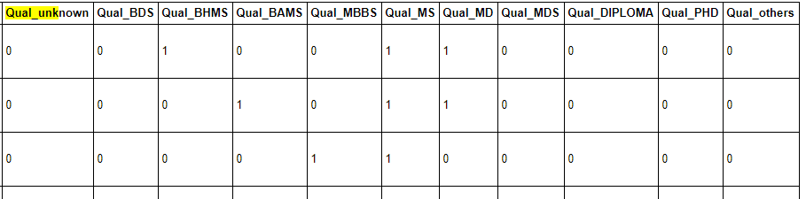
New features derived from Place: The Place variable contains 2 values in each cell, area and city. Two new features ‘Area’ and ‘City’ are created by extracting information from the Place variable. Click here to view the code.
The Area and City are extracted from Place as follows;
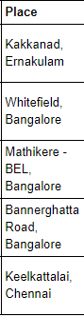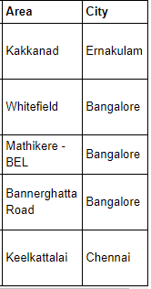
The Miscellaneous_Info variable contains some miscellaneous details like rating, number of feedbacks and place and in some cases the fees of the doctor. Rating and Place already exist in the dataset as separate features. I also extracted the Number of feedback and the fees values in the Miscellaneous_Info and created 2 new Features out of these.
New Features ‘Number_Feedback’ and ‘Approx_Fees’: Around 43.9% values are missing in Miscellaneous_Info in trainset and 13.9% values missing in Miscellaneous_Info in the test set. So, before creating the new features, we need to impute the missing values in the Miscellaneous_Info.
The custom methods extract_feedback_number() and extract_approx_fees(), first fill the missing values in Miscellaneous_Info with ‘No comments’, then extract the number of feedback and the approximate fees value from the Miscellaneous_Info respectively and then create new features out of it. Click here to view the code.
Sample screenshot
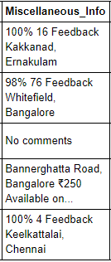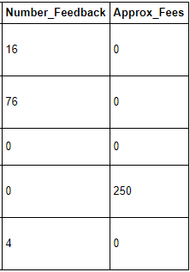
There are some records with Qualification as "Get inspired by remarkable stories of people like you" which seems invalid and occurring a few times in both train and test sets. I updated the Approx_Fees for these records with the actual Fees to help the model to predict the Fees better for these invalid inputs. The Actual Fees for these records are all 100.

Data Encoding:
The dataset has a few categorical variables. These variables need to be converted to numerical variables.
Miscellaneous_Info:
To utilize the information in Miscellaneous_Info(), I created a new Feature named ‘Misc_Info’ and marked 0 if Miscellaneous_Info is ‘No comments’ else 1. Click here to view the code.
Screenshot:
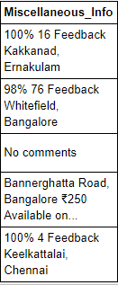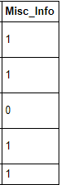
City and Profile:
The City variable has 10 categories in train set and 9 categories in test set. There is one additional category in the trainset - 'Sector 5'. If get_dummies() is used, this will create a mismatch in the number of columns between the train and the test datasets. The Profile variable has 6 categories in both train and test sets. I will use OneHotEncoding for both the variables. Visit GitHub for to view the code.

OneHotEncoded City variables:
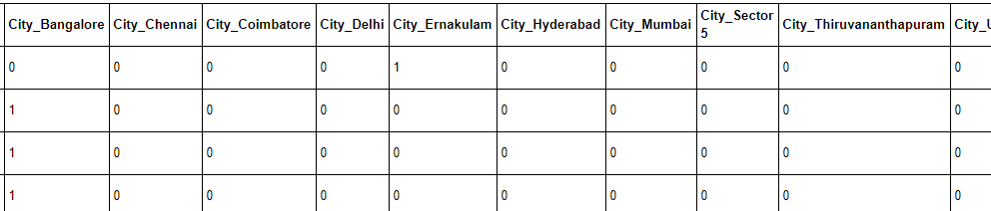

OneHotEncoded Profile variables:
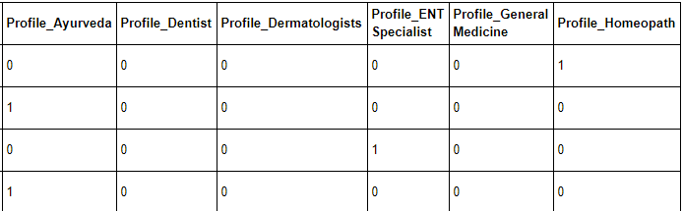

Area:
There are a total of 937 unique values in Area variable. I created a dictionary of Area categories as keys and corresponding numerical values as values for train and test sets.
The encode_area() method is used to set numerical variables for each of the values in the Area variable in both train and test sets. Created a new feature ‘Area_Codes’ with the area codes. Click here to view the code.
Screenshot:
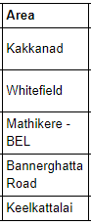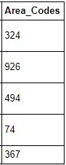
The ‘Area’ variable is encoded as ‘Area_Codes’ in an ordinal fashion. Since the categories in ‘Area’ were not ordinal, it is not a good idea or not enough to just assign some numbers to each category. Because the model will consider that one number is higher than the other which is not the case with the ‘Areas’. One area is not above or below another area. So, we need some kind of a binary encoding for each of the categories in the Area_Codes. Binary encoding will be done post Exploratory Data Analysis.
Descriptive statistics of the trainset:
Done using .describe() method from pandas. Click here to view the code.
- 'Qualification' has 1420 unique categories in it. BDS shows as the most frequent category in the train dataset occurring 488 times out or 5961 records. This actually only representing doctors who did only BDS alone. Since there are multiple degrees in most of the fields, the actual most frequent individual degree/category could be different.
- Experience ranges from 0 to 66 years. It is right skewed. There could be outliers in the feature. At least 25% of the doctors in the training dataset is less than 10 years. At least 25 % of the doctors in the training dataset have more than 23 years’ experience.
- Rating, ranges from 0 to 100. Since there were around 50% missing values, and those were filled with 0s, now the feature has at least 50% if the values as 0. At least 25% of the values are greater than 96. The variable is highly positively skewed.
- Profile has 6 unique categories. Dentist is the most frequent category occuring about 1397 times out of 5961 records.
- Fees ranges from 5 to 950. It is slightly right skewed. There could be some outliers. At least 25% of the data is 500 and greater. There are also some very low values in the Fees(target) variable.
- Number_degrees_diploma_certificate ranges from 1 to 10. Al least 75% of the doctors have done 2 and lesser number of degrees/diplomas/certificates. There could be some outliers.
- From the encoded Qualification features, we can see that at least 25% of the records have MBBS, MS, MD degrees. The other degrees are all less than 25%.
- Area has 866 unique categories. HSR Layout is the most frequent category, occurring 75 times in the dataset.
- City has 10 unique categories. Bangalore is the most frequent category, occurring 1259 times in the dataset.
- Number_Feedback ranges from 0 to 1782. At least 75% of the records have 1 and no feedbacks. At least 50% of the records do not have any feedbacks. There could be outliers. It is highly positi vely skewed.
- Approx_Fees ranges from 0 to 2500. At least 75% of the values are 0s. It is right skewed.
- Misc_Info shows that at least 50% of the record has some misc. information.
- Area_Codes ranges from 0 to 936. It is a discrete variable. It is slightly right skewed.
- The encoded City variables show that all the Cities are occurring only less than 25% of the times in the dataset.
- The encoded Profile variables show that all the profiles are occurring only less than 25% of the times in the dataset.

Exploratory Data Analysis:
Click here for code in GitHub.

Analysing Fees based on Experience of the Doctor.
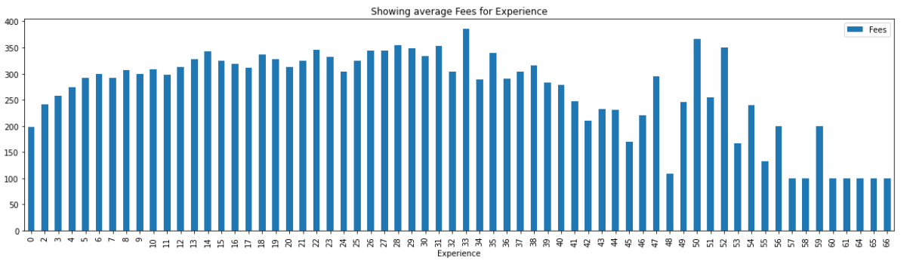
Observations:
- Most doctors in the trainset have 8 to 12 years of experience.
- There are 323 doctors who have 9 years’ experience
- There are very less doctors who have more than 50 years’ experience.
- Doctors with 33 years of experience get the highest average Fees. Followed by Doctors with 50 and 52 years of experience.
- The average Fees is also decreasing significantly as the years of experience is beyond 60. This can actually be related to the Profile and Qualifications of the doctors in that experience group since we do not have many records in that sample. Also, there is a chance of Charity and Free for poor schemes many doctors usually do.

Analysing Fees based on Doctor's encoded Qualifications:
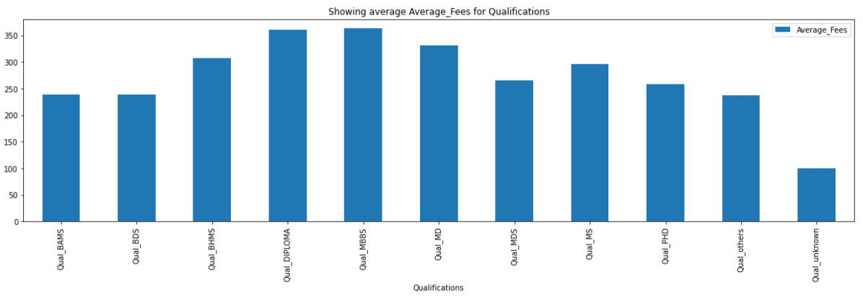
Observations:
- All these Qualifications may have a combination of other degrees also.
- Records that have MBBS as one of the combinations in Qualification variable, seem to have the highest Average Fees.
- Doctors with some Diploma along with some degree seem to have the second highest average fees.
- The lowest Average Fees is for records with Qualification Unknown which was actually the invalid records we had.

Analysing Fees based on Rating:
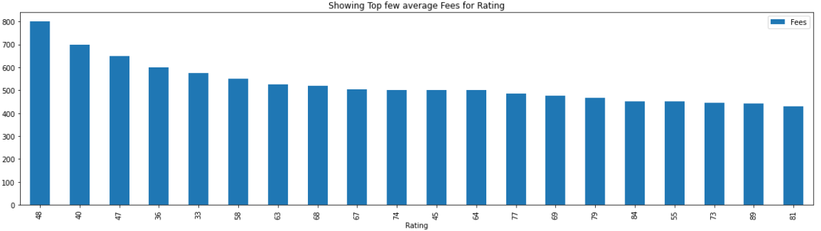
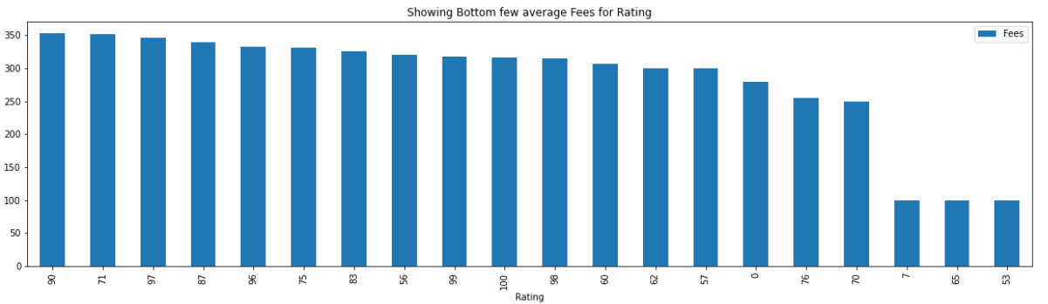
Observations:
- Some of the highest average Fees are for Ratings that have lesser number of records.
- The average Fees for most of the higher ratings are less than 350 INR.
Analysing Fees based on Profile:
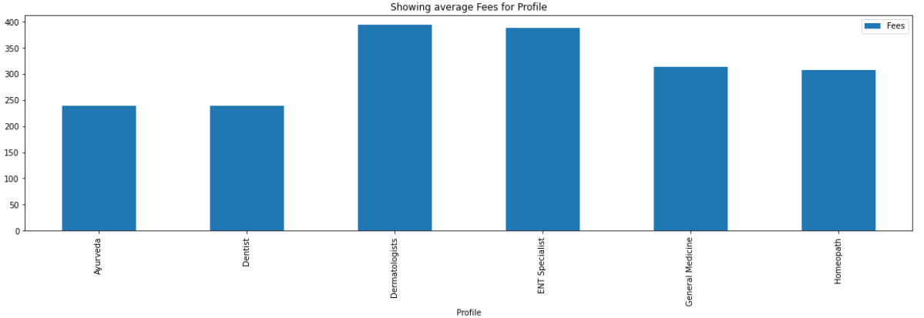
Observations:
- Dermatologists earn the highest average Fees followed by ENT Specialists.
- Lowest Average Fees is earned by Dentists.

Analysing Fees for each Profile based on City
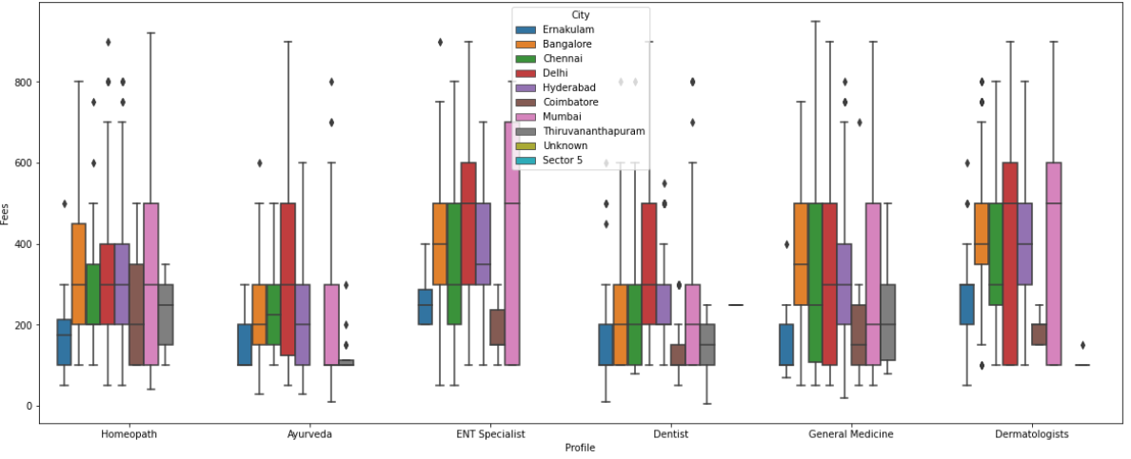
Observations:
- For Homeopathy Doctors, the highest fee is in Mumbai and the lowest is in Ernakulam.
- For Ayurvedic Doctors, the highest fee is in Delhi and the lowest average Fee is in Thiruvananthapuram and Ernakulam.
- For ENT related Specialist doctors, the highest fee is in Delhi and the lowest is in Thiruvananthapuram and Bangalore. In Coimbatore also the whole range of Fees is pretty low.
- For Dentists, the highest fee is in Delhi and the lowest is in Thiruvananthapuram. The lowest range of fees is in Coimbatore.
- For General Physicians, the highest fee is in Chennai however, the highest average Fees is in Bangalore. The lowest fee is in Hyderabad. The lowest range of fees for General Medicine is in Ernakulam.
- For Dermatologists, the highest fee is in Delhi and Mumbai. The lowest fee is in Ernakulam. The lowest range of fees is in Coimbatore.

Analysing Fees for each Profile based on Number of degrees the Doctor hold
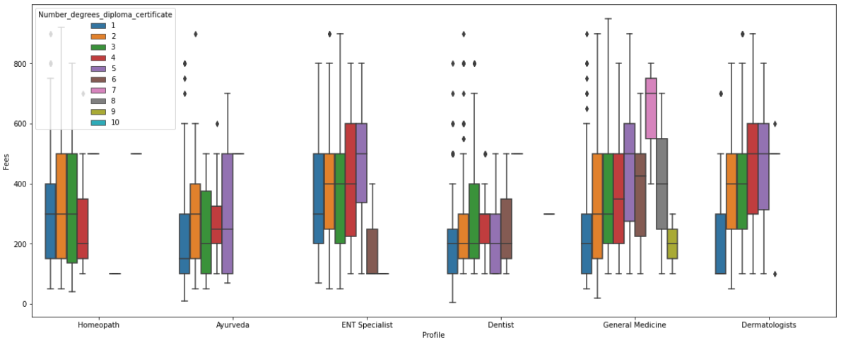
Observations:
- For Homeopathy Doctors, the highest fees collected by Doctors with 2 Degrees or Diplomas or certificates.
- For Ayurvedic Doctors, the highest fees collected by Doctors with 5 Degrees or Diplomas or certificates and the lowest fees is collected by Doctors with just 1 Degree.
- For ENT related Specialist doctors, the highest average fee is collected by Doctors with 5 Degrees or Diplomas or certificates and the lowest range of fees is collected by doctors with 6 Degrees or Diplomas or certificates.
- The lowest fee is collected by doctors with 2 or 3 Degrees or Diplomas or certificates.
- For Dentists, the highest fees collected by doctors with 3 Degrees or Diplomas or certificates and the doctors with just 1 degree collect the lowest fees.
- For General Medicines, the highest fee is collected by doctors that have 3 Degrees or Diplomas or certificates. The lowest fee is collected by doctors that have 2 Degrees or Diplomas or certificates.
- For Dermatologists, the highest fees are collected by doctors that have Degrees or Diplomas or certificates. The lowest fees are collected by doctors with 2 Degrees or Diplomas or certificates.
Correlation:
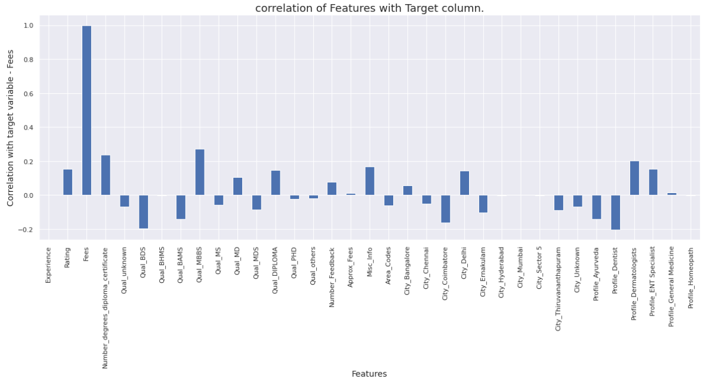
The Qual_MBBS and Number_degrees_diploma_certificate have the top 2 correlations. However, it is only 25% and 23%. Rest of the correlation is spread across all the features for Fees variable. Click here to view the code.
Outliers:
There are some outliers in the dataset. The below figure shows the outliers in the variables. Click here to view the code.
Before removing outliers:
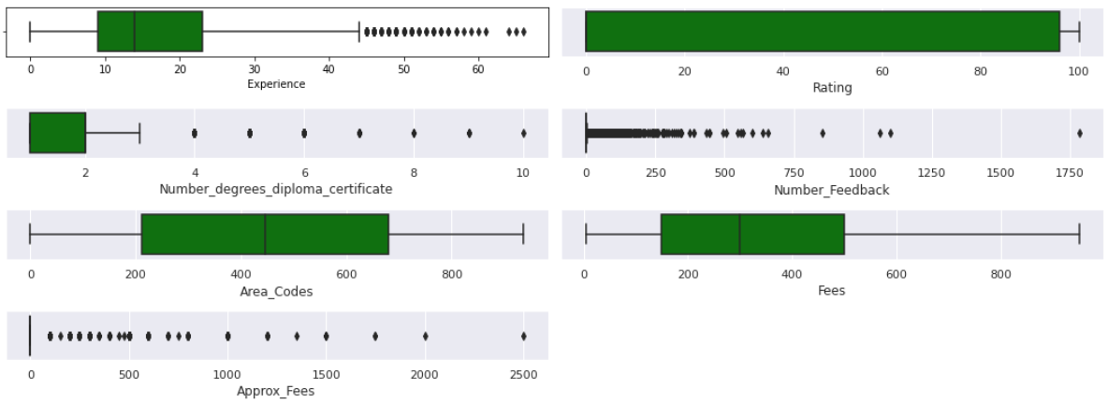

After removing the outliers:
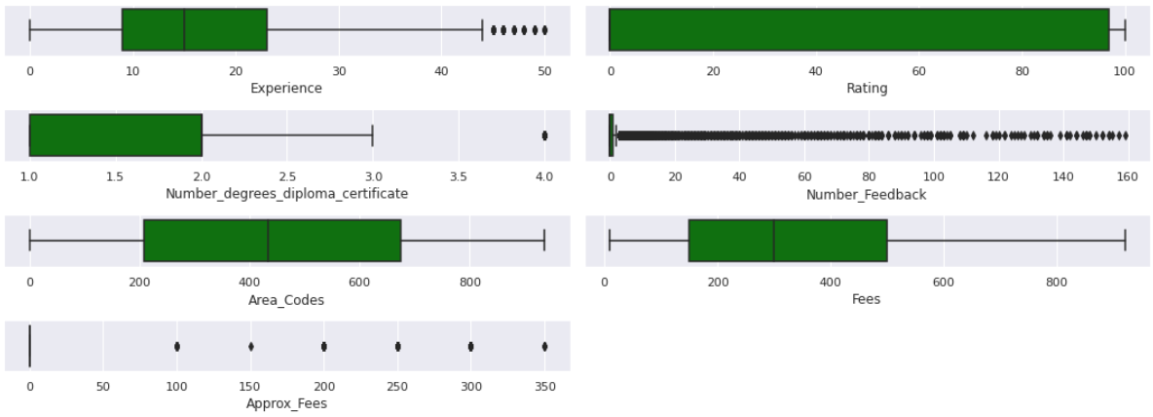
Observations:
About 14% of the data are identified as outliers which is a lot of data to lose. Many potentially important information is being removed in Number_degrees_diploma_certificate and Experience. It’s better to leave the outliers as they are.

Feature Selection:
We will be using the following features for further analysis and model training.
'Experience', 'Rating', 'Number_degrees_diploma_certificate', ’Qual_unknown', ’Qual_BDS', 'Qual_BHMS', 'Qual_BAMS', 'Qual_MBBS', 'Qual_MS', 'Qual_MD', 'Qual_MDS', 'Qual_DIPLOMA', 'Qual_PHD', 'Qual_others', 'Number_Feedback', 'Approx_Fees', 'Misc_Info', 'Area_Codes', 'City_Bangalore', 'City_Chennai', 'City_Coimbatore', 'City_Delhi', 'City_Ernakulam', 'City_Hyderabad', 'City_Mumbai', 'City_Sector 5', 'City_Thiruvananthapuram', 'City_Unknown', 'Profile_Ayurveda', 'Profile_Dentist', 'Profile_Dermatologists', 'Profile_ENT Specialist', 'Profile_General Medicine', 'Profile_Homeopath'
Click here to view the code.
HashingEncoder on Area_Codes:
There are 866 unique values in Area_Codes in the train set. If we use OneHotEncoding or get_dummy(), we will end up having an additional 866 features. This is not a great news for the model. Hence, I am doing a Hash encoding on the Area Codes. HashingEncoder allows us to have lesser number of features than the actual number of categories in the variable being encoded because it uses hashing technique.
HashingEncoder has a hyperparameter ‘n_components’ which indicates the number of features expected as output after encoding. Now the question, what is the optimum n_components to use for our data. To answer this, I looped through a range of numbers, used those numbers as the n_components to apply HashingEncoder on the dataset. Then trained and tested a LinearRegression model using the encoded data and found the value for the n_components that gave the least Root Mean Squared Error. For our train set, the optimum ‘n_components’ is 480. Finally, used 480 as the n_components to Hash encode the Area_Codes variable. If we had used OneHotEncoding or get_dummy() we would have had more than 480 new features. Click here to view the code.
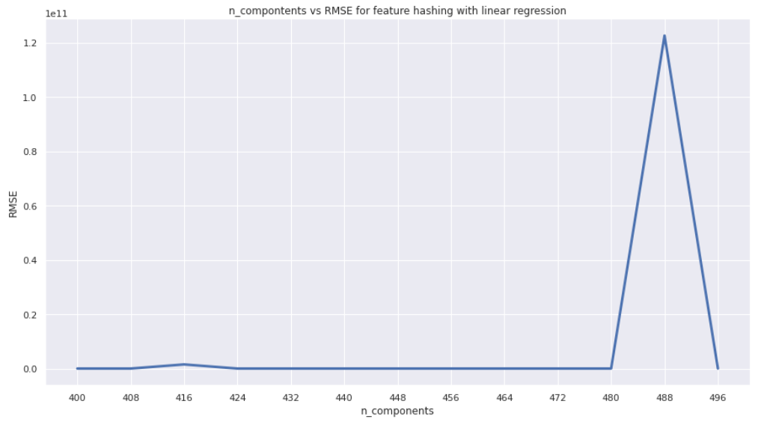
The lowest RMSE in Linear Regression is 135.600838805214 for n_components of 480.
Data Pre-processing Pipeline:

Data Scaling and Transformation:
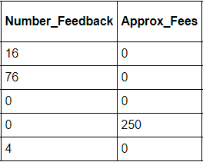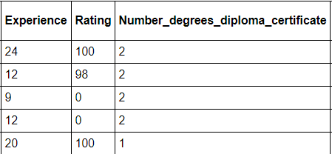
We can see that the data is in different scale. I have used Robust scaler to scale the data.
I used RobustScaler to scale the features and StandardScaler to scale the target variable ‘Fees’. Click here to view the code.
Skewness:
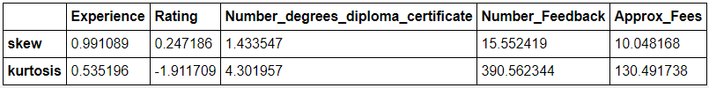
The Features Experience, Number_degrees_diploma_certificate, Number_Feedback and Approx_Fees have high positive skews. We will need to do a transformation to reduce the skewness.
The Fees variable is also slightly positively skewed with a skewness of 0.75187. I have used PowerTransformer to transform the data in order to reduce the skewness. Click here to view the code.
The target variable is also scaled and transformed. We can reverse the scaling and transformation on Fees using the following code:
sc_y.inverse_transform(pt_y.inverse_transform(y_pt))
Note: The Final pre-processed train data are x_pt, y_pt and the final pre-processed test dataset is test_data_enc_pt.
Building Machine Learning Models:
I will use the training set to train the model. Before building the model, we need to find a suitable model to use for this problem. In this project we are predicting the Fees values which is a continuous data. Hence, we will use Regression models. To find which regression model to use, we need to find which model gives the lowest error while predicting the Fees. To find that we need to split the training set into train and test set, then train different Regression models using the train set and then validate the results using the test set we get in the train test split. We need to find an optimum Random state to split the training dataset into train and test sets.
Finding the optimum Random State:
I used GradientBoostingRegressor model to validate the train test split. The following is the result of finding optimum random state.
random state: 895, Train Error: 0.798518052504794, test score: 0.7933586715818275 Variance: 0.005159
I used Random state as 895 to do the train_test_split() from sklearn library.
Finding variables with zero variance:
At this point, we have about 513 features in the input variable as a result of encoding and feature selection. There is a possibility that the HashingEncoder has introduced some features that has only 0s or 1s throughout the data. These features are of no use for the model because they won’t have any variability in them for the model to learn. And they add to the train and prediction time without adding any value. Hence, I checked if there are any features in the input to drop those features from the input while training the model and prediction.
There are 102 features that have variance = 0. These can be dropped to speed up the model. The feature names with variance = 0 are stored in the object 'zero_columns'. To view the code, click here.
Finding the best model:
I used cross_val_score method from sklearn library to experimented with LinearRegression, Lasso, Ridge, SVR, DecisionTreeRegressor and KNerighborsRegressor algorithoms to find the best model for this problem. The Ridge model gave the best result.
Model: Ridge
Root Mean Cross val error: 0.869772140686895
Variance: 0.03551206577874414
To view the code, click here.
Ensemble Techniques:
I wanted to check if the ensemble models can perform better with the dataset, we have with us. I performed cross_val_score on the XGBRegressor, RandomForestRegressor, GradientBoostingRegressor and AdaBoostRegressor. The RandomForest, XGBoost and GradientBoost are performing better than the others with the following are the results:
Model: XGBRegressor || Root Mean Squared error: 0.8400200892859699 || Variance: 0.041960030354205737
==================================================
Model: RandomForestRegressor || Root Mean Squared error: 0.8309426780177789 || Variance: 0.052302192473052005
==================================================
Model: GradientBoostingRegressor || Root Mean Squared error: 0.8406889945224826 || Variance: 0.041300678478009265
==================================================
To view the code, click here.

Overall Observations:
- The Ensemble techniques are on the whole performing better than the Ridge model.
Hyper-Parameter Tuning:
I selected the RandomForestRegressor, XGBRegressor and GradientBoostingRegressor to further tune the hyper-parameters of these models to see if the performance is increasing. Since there are many features and I am using ensemble models, I used RandomizedSearchCV to do the hyper-parameter tuning to save time. To view the code, click here.
XGBRegressor: Best RMSE = 0.8372875536129213 and the best hyperparameter values are {'n_estimators': 150, 'max_features': 'auto', 'max_depth': 2, 'learning_rate': 0.5}
RandomForestRegressor: Best RMSE = 0.8093049115309026 and the best hyperparameter values are {'n_estimators': 400, 'max_samples': 0.8, 'max_features': 'sqrt', 'max_depth': 60, 'criterion': 'mse'}
GradientBoostingRegressor: Best RMSE = 0.8098716037840583 and the best hyperparameters are {‘n_estimatores’: 200, ‘max_features’: ‘log2’, ‘max_depth’: 30, ‘loss’: ‘huber’, ‘learnings_rate’: 0.03, ‘criterion’:’mse’}

Finding the Final Model:
Now that we have all the hyperparameter values, I used cross_validate to experiment with tuned XGBRegressor, tuned RandomForestRegressor and tuned GradientBoostingRegressor models to see which one performs well. To view the code, click here. The following are the results:
Model: RandomForestRegressor || Mean Cross RMSE: 0.8132905511977248 || Variance RMSE 0.0007507737243580339 Mean Cross MSE: 0.662192294391857 || Variance MSE 0.0020139787510952177
Hyperparameters used: 'n_estimators': 400, 'max_samples': 0.8, 'max_features': 'sqrt', 'max_depth': 60, 'criterion': 'mse'
==================================================
Model: XGBRegressor || Mean Cross RMSE: 0.841605450801692 || Variance RMSE 0.0006569776959387396 Mean Cross MSE: 0.7089567125150579 || Variance MSE 0.0019099581021368287
Hyperparameter used: 'n_estimators': 150, 'max_features': 'auto', 'max_depth': 2, 'learning_rate': 0.5
==================================================
Model: GradientBoostingRegressor || Mean Cross RMSE: 0.8138422055861166 || Variance RMSE 0.0006620232565044366 Mean Cross MSE: 0.6630011588497793 || Variance MSE 0.0017802586331116914
Hyperparameter used: ‘n_estimators’:200, ‘max_features’:’log2’,’max_depth’:30,’loss’:’huber’,’learning_rate’:0.03,’criterion’:’mse’
Manual updates to hyperparameters:
I did some manual updates to the hyperparameters based on some trail-error and some intuitions and obtained a slight reduction in the errors. The following are the results:
Model: RandomForestRegressor || Mean Cross RMSE: 0.812181487331803 || Variance RMSE 0.0007184422403169182 Mean Cross MSE: 0.6603572106048168 || Variance MSE 0.0019159532295586097
Hyper-parameter values used: n_estimators = 800, max_samples = 0.8, max_features = ‘sqrt’, max_depth = 50, criterion = ‘mse’
==================================================
Model: XGBRegressor || Mean Cross RMSE: 0.8303175377975585 || Variance RMSE 0.0004989133720181329 Mean Cross MSE: 0.689926126946218 || Variance MSE 0.0014036606499232098
Hyperparameter used: objective = ‘reg:squarederror’, 'n_estimators': 85, 'max_features': 'auto', 'max_depth': 6, 'learning_rate': 0.2
==================================================
Model: GradientBoostingRegressor || Mean Cross RMSE: 0.8100832246638351 || Variance RMSE 0.0005579254708135266 Mean Cross MSE: 0.656792756352571 || Variance MSE 0.001482790093235556
Hyperparameter used: ‘n_estimators’:150, ‘max_features’:’log2’,’max_depth’:35,’loss’:’huber’,’learning_rate’:0.02,’criterion’:’mse’
Observations:
The GradientBoostingRegressor and RandomForestRegressor are performing better than XGBoost.
Performing Cross validation on the whole Training set:
Performing Cross Validation on GradientBoostingRegressor and RandomForestRegressor with the whole training dataset.
I performed cross validation on the tuned GradientBoostingRegressor and RandomForestRegressor models, to see how these models perform on different combinations of train and validation sets from the training dataset. To view the code, click here.
- The GradientBoostingRegressor is giving an MSE of 0.641 and an RMSE of 0.800 and RandomForestRegressor is giving an MSE of 0.643 and an RMSE of 0.801.
- The variance in both the models are pretty negligible at 10^-05 range. Hence, I am choosing GradientBoostingRegressor based on the slightly lesser error.

Building the final model:
The final model used is the GradientBoostingRegressor with the tuned hyperparameters n_estimators = 150, max_features = 'log2', max_depth = 35, loss = 'huber', learning_rate = 0.02, criterion = 'mse'.
The model is then trained with the whole training set. The joblib library is used to serialize the trained model to save the model for production. To view the code, click here.
Predicting the Fees values for the pre-processed test dataset:
The pre-processed test dataset is referenced by ‘test_data_enc_pt’. The final trained model is saved in serialized form as a .obj file. It can be loaded and de-serialized using the joblib library.
Predictions:
To predict the output, use the predict() method.
Note: Remember that the predictions are in the form of scaled and transformed data. So, the predictions need to be reversed using inverse_transform() method from StandardScaler and PowerTransformer. To view the code, click here.
screenshot of predictions:
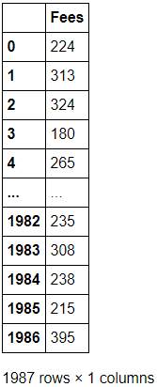
The above predictions can be saved as a .csv file using the to_csv() method in pandas’ DataFrame.
Concluding Remarks:
We used multiple features to train the model and make the predictions. The following plot shows the top 60 important features that impacts the final model in making predictions. This gives us an idea about the factors that can really affect the Doctor’s consultation Fees.
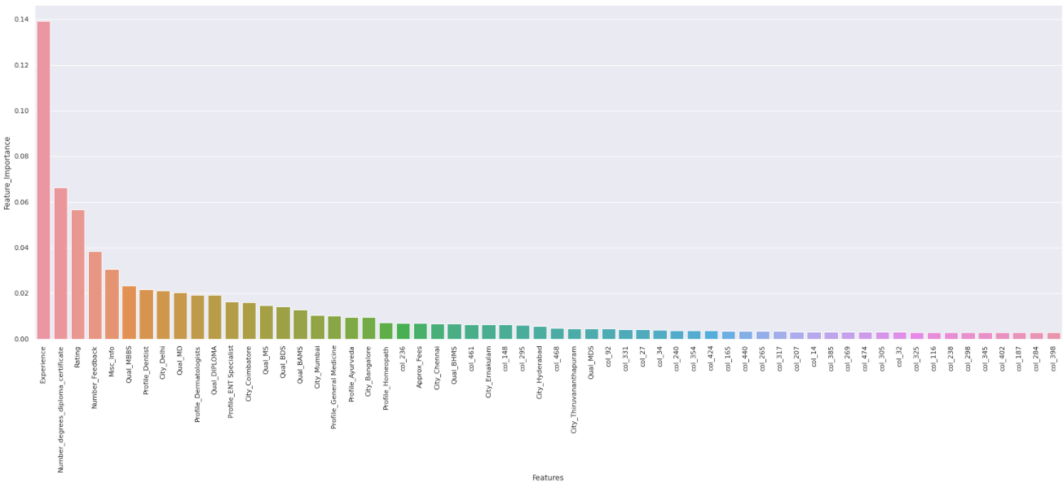
- Experience plays a very important role in the prediction of the Doctor's fees.
- Following Experience, the Number of degrees the doctor holds and the Rating for the doctor is playing a vital role.
- The doctor's Qualification and the profile also plays a significant role but only after the Experience, Number of degrees and the rating.
- Finally, the city in which the Doctor is serving is also affecting the Fees.

